**Website Analysis Project – Tovkach Pavel IRM-354**

<https://activsb.by>

**1. Usability:**

**On the usability side, the site is quite convenient and intuitive, all the necessary information is displayed on the main screen, the catalog is almost at the very beginning and is in tabs, the only thing I would put the popular products at the very beginning, not at the very bottom.**

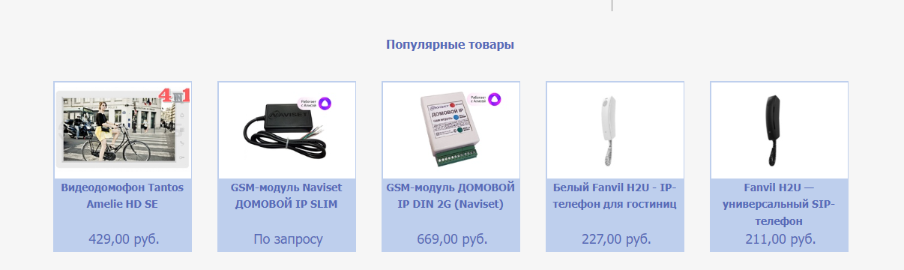

**I would like to highlight a convenient system for searching for products, both by name and by category.**

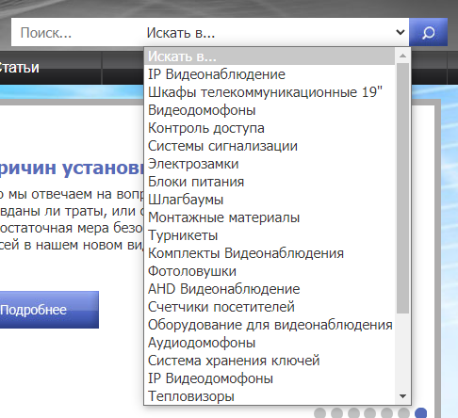

**From minuses and inconveniences, there is no other language except Russian, there is no mode for people suffering from color blindness and consultant-assistant.**

**2. Design:**

**Overall the design is very simple and visibly outdated, not reflecting the modernity of technology. I doubt that it attracts customers, rather only regular customers go there because they know about the availability of goods on the site.**

**The price is listed incorrectly, with two more digits after the comma, making the price visually large and making the buyer wonder about the purchase price.**



**It is not clear selected color scheme, the logo is black and gray, and the colors of the site for some reason bright and dull.**

**Also on the example of popular products we can see how the background is almost the same color as the name of the product, which strains the eyes and does not highlight it.**

**On fonts I would single out not successfully chosen font for numbers, catches the eye and stands out on the background.**

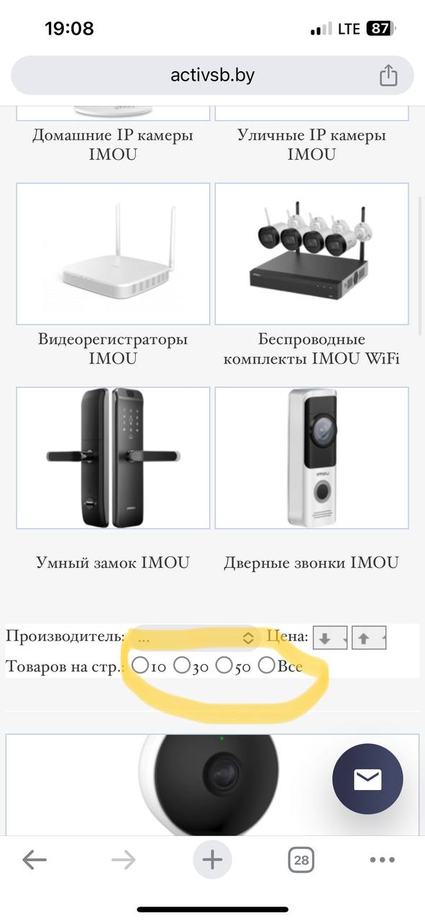

**On fonts I would single out not successfully chosen font for numbers, catches the eye and stands out on the background. The font is ordinary, nothing stands out, it's not good and not bad, everything is readable, but the main information is not highlighted.**

**3. Responsiveness:**

**One of the pluses I'll highlight is the adaptation for different screens. On the mobile version I like the site more than on the computer version, the catalog immediately catches the eye and nothing superfluous, information about the company at the very bottom. The only thing is that in the mobile version of the pictures get on the text.**

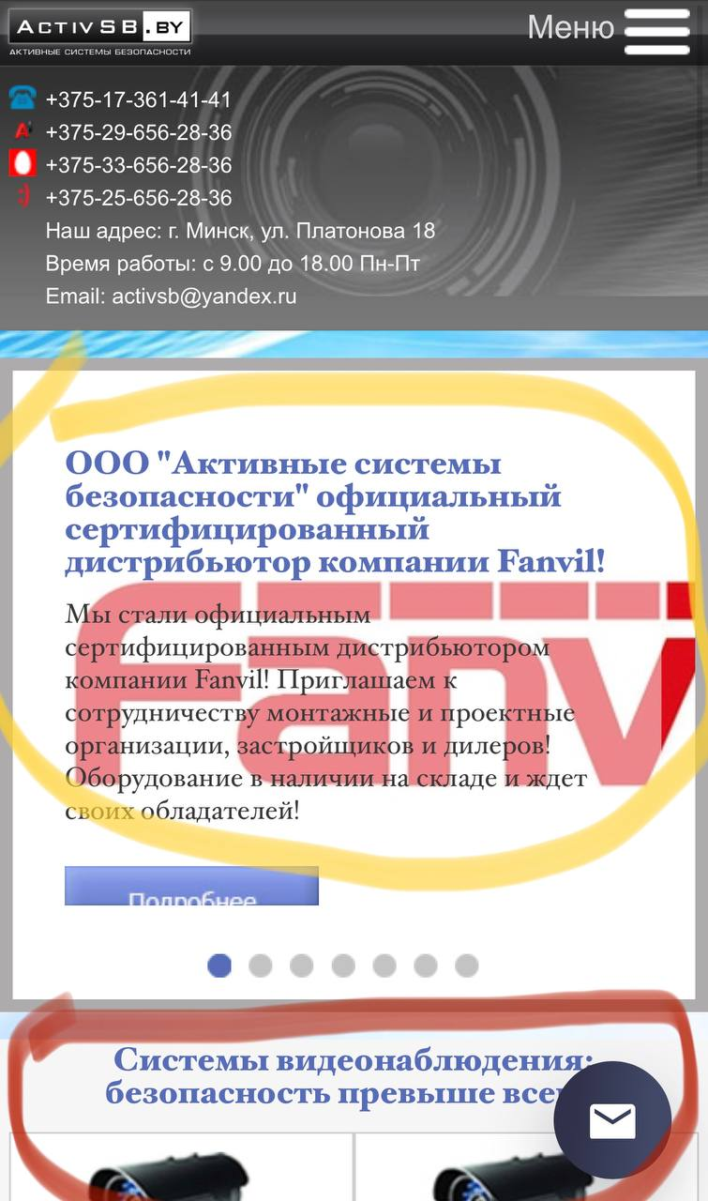

**It seems that the site was originally designed for mobile devices, because the site looks pretty good on them.**

**4. Performance:**

**Surprisingly with the optimization is all good, fast loading both on wired and mobile internet. Fast response and work of the site. All information is loaded at the same time.**

**Pictures are compressed and loaded without loss of quality for a small amount of time.**

**5. Search Engine Optimization (SEO):**

**When searching, the site displays recent queries, which may make it easier for consumers to find the product they are looking for.**

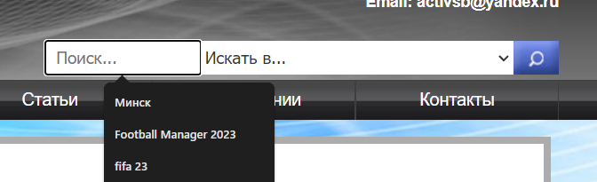

**I didn't see any header tags(**

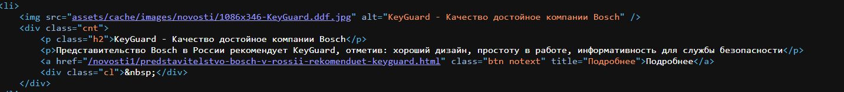

The link navigation is there and works well, the user can navigate through tabs and links without any problems.

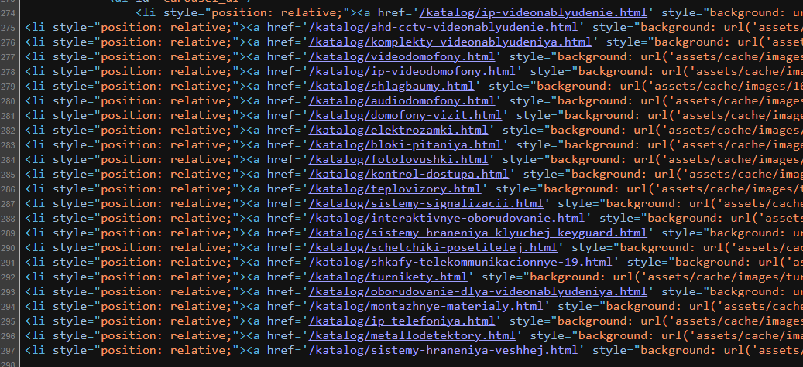

**Additional Considerations:**

Overall, the site is clear enough for consumers of all ages, the only thing I would do is highlight the most important information in a different color that stands out from the background.

The site has long been outdated and requires design improvements in terms of modern trends, the product is still relevant and news appear until now, but the design has not changed, but despite all the shortcomings mentioned above, the site performs its function.

Examples of competitors' websites:

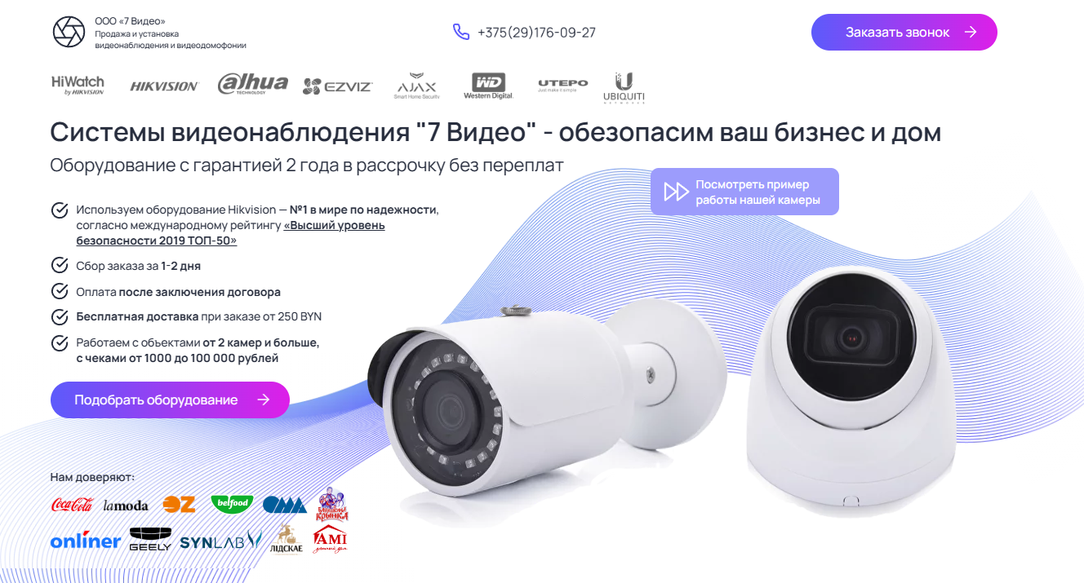

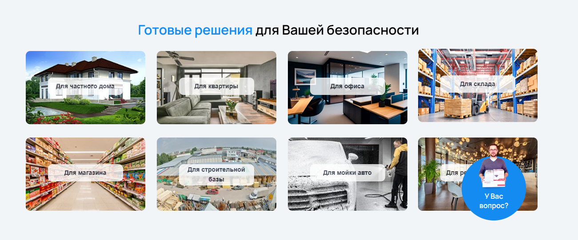

As I wrote before about the online assistant.

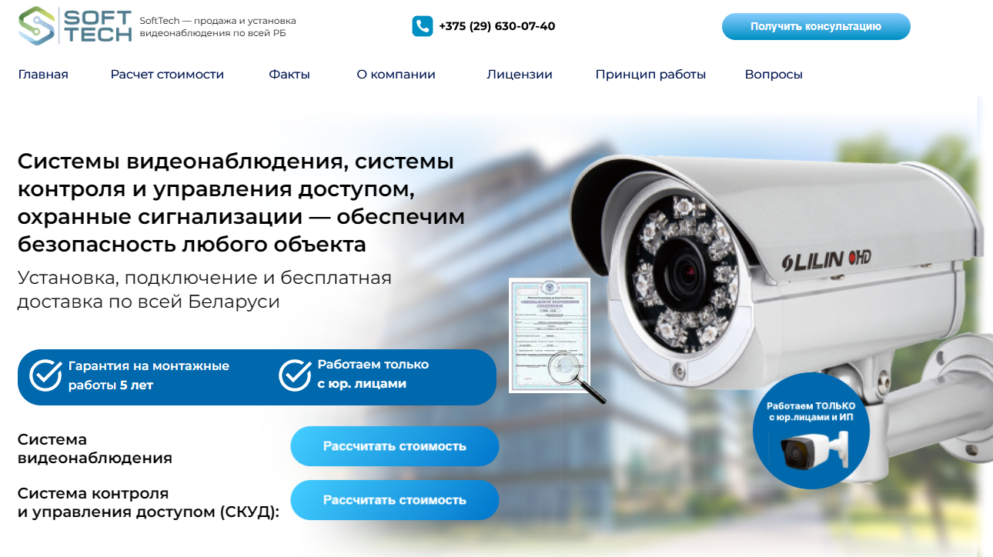

We can summarize that competitors' sites look more modern, but in terms of functionality they are not much ahead.

My FINAL RESULT:

